RESEARCH NOTE
From: Laila Poisson
DATE: January 8, 2014
RE: Patient characteristics for GBM samples with RNA-seq data
Recently we have been interested in the RNA-seq measures of messenger RNA (mRNA) expression for glioma produced by The Cancer Genome Atlas project (TCGA). The glioblastoma arm (GBM) of TCGA was initiated in 2006 prior to common use of next-generation sequencing for mRNA assay. Therefore mRNA expression was assayed by Affymetrix and/or Illumina microarray for these tumor samples. RNA-sequencing has been performed retrospectively on those samples with remaining tissue and/or banked Total RNA.
Started more recently, the lower-grade glioma arm (LGG) of TCGA uses only RNA-sequencing to assay mRNA expression levels. Glioblastoma represents a grade 4 glioma and it is of interest to look at expression levels across the LGG and GBM arms of TCGA. Since RNA-sequencing was not part of the original protocol there is a risk that the GBM patients with this data are not representative of the TCGA-GBM case set.
This research note compares the GBM samples in TCGA with RNA-seq data to those without for key clinical features. Specifically we focus on the age at diagnosis, sex, Verhaak molecular classification, and overall survival.
Data Used
The normalized RNA-seq data were downloaded from the Broad Institute Firehose Standard Data collection for GBM (run date: 12-10-2013). The SRDF file was used to indicate samples with RNA-seq data. Clinical data were downloaded from the Cell 2013 biomarker paper for GBM (Table S7).
The two data files were merged on TCGA patient barcode in SAS (v9.2). Only primary tumors were retained. Matched recurrent tumors were excluded. Overall survival was already calculated as the days from diagnosis to death. Those still alive have a censored survival time as the months from diagnosis to the time of last follow-up. A working data file was exported for further analysis.
Analysis
The working data file was loaded into SPSS (v22) for analysis. A two-sample t-test with equal variance assumption was used to compare groups for continuous variable age. Chi-square tests were used to compare groups for the categorical variables sex and Verhaak class. Kaplan-Meier estimates and a log-rank test were used to compare overall survival between groups.
Results
There are 516 primary tumors with clinical data given in Table S7 of the Cell paper. There are 154 primary tumors with RNA-sequencing data. Two samples with RNA-seq data did not have clinical data available and were excluded. One case with RNA-seq data (TCGA-15-5411) did not have age, sex, or survival data recorded and was also excluded. In the following analysis we have 151 cases with RNA-seq data (29.3%) and 364 cases (70.7%) without. The results are summarized in Table 1.
Table 1. Comparison of key clinical parameters between samples with and without RNA-seq data
 |  | RNA-Seq Data
 |  | YES (N=151) | NO (N=364) | P-value
Age at Diagnosis | Mean +/- SD | 60.7 +/- 13.1 | 58.3 +/- 14.4 | 0.071
Sex assigned at birth | Male (%) | 96 (63.6%) | 224 (61.5%) | 0.664
 | Female (%) | 55 (36.4%) | 140 (38.5%)
Verhaak Expression Class | Classical (%) | 39 (25.8%) | 100 (27.5%) | 0.374
 | G-CIMP (%) | 8 (5.3%) | 23 (6.3%)
 | Mesenchymal (%) | 49 (32.5%) | 105 (28.8%)
 | Neural (%) | 26 (17.2%) | 53 (14.6%)
 | Proneural- (%) | 28 (18.5%) | 68 (18.7%)
 | Unknown (%) | 1 (0.7%) | 15 (4.1%)
Overall Survival (months) | Median (95% CI) | 13.53 (11.6, 15.5) | 13.47 (12.2, 14.7) | 0.674

The difference in mean age is nearly statistically significant at p=0.071 (t-test, using an 0.05 threshold). This suggests that those cases with RNA-seq data tend to be older (mean: 60.7 years) than those without (mean: 58.3 years). However, it is not clear that a 2.4 year difference in average age of diagnosis is clinically meaningful. When we look at the distributions of the two groups in Figure 1, we see that they are very similar and it’s possible that the lower mean age in the group without sequencing may be due to the few persons in the group with diagnosis before 20 years of age.
Figure 1. Distribution of age at diagnosis for cases with and without RNA-sequencing data
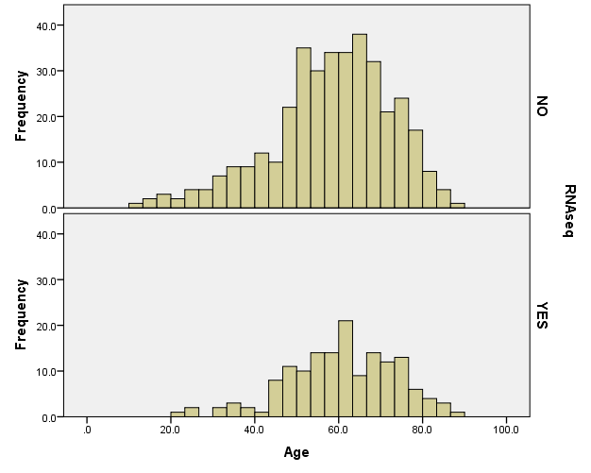

The proportion of males and females is well balanced between the two groups (Chi-square, p=0.664). Likewise the proportion of cases in each molecular class is similar between the two groups (Chi-square, p=0.374).
The estimated median survival is nearly identical at approximately 13.5 months for those with and without RNA-seq data. The log-rank test confirms that there is no evidence of a difference in the survival distributions between the two groups (p=0.674). This is depicted in the Kaplan-Meier plots of Figure 2. Here the survival curve for cases with RNA-seq data are shown in green (solid line and square censoring markers) and the survival curve for cases without RNA-seq data are shown in blue (dotted line and circle censoring markers).

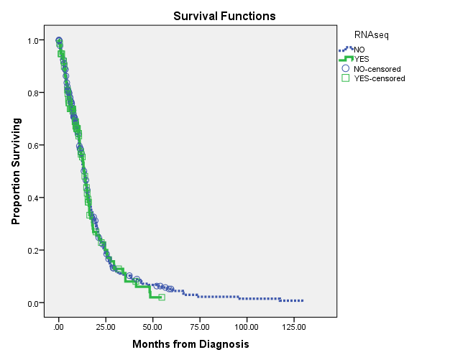

Conclusion
For the clinical variables considered here, there is no evidence that the cases with RNA-sequencing data differ significantly from those without RNA-sequencing data. This is reassuring that the samples with RNA-seq data are likely a representative sample of the whole set. It is interesting to note that 34.4% of the cases with RNA-seq data were alive at last follow-up compared to only 19.6% of the cases without RNA-seq data. Since the survival curves do not differ, this suggests that the samples with RNA-seq data are likely newer diagnoses. The year of diagnosis should be considered before using RNA-seq data on studies of treatment regimens as they have changed notably over the last decade.

gdac.broadinstitute.org_GBM.Merge_rnaseqv2__illuminahiseq_rnaseqv2__unc_edu__Level_3__RSEM_genes_ normalized__data
https://confluence.broadinstitute.org/display/GDAC/Home
Brennan, Verhaak, et al.(2013) The Somatic Genomic Landscape of Glioblastoma. Cell. 155:462-477.
M:\lpoisso1\TCGAdata\RNAseq\GBM\ClinCheck_RNAseqSamples.sas
M:\lpoisso1\TCGAdata\RNAseq\GBM\ClinicalData_withRNAseqStatus.txt
M:\lpoisso1\TCGAdata\RNAseq\GBM\ClinicalDataComparison_RNAseqStatus.spv

